### contacts

West Essex & East Herts Guild of

Spinners, Weavers & Dyers

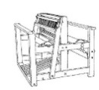

#### Threads

#### 

#### **December 2015**

|  |  |
| --- | --- |
| Chair | Carolyn Green |
| Vice-Chair | Lesley Ottewell |
| Secretary | Mary Hicks |
| Treasurer | Cate Barnett |
| Publicity Officer | Asela Ali |
| Programme Secretary | Sue Prior |
| Committee Member | Chris Lane |
| Guild Website  www.westessexeasthertswsd.weebly.com | |  |
|  |  |



**Members of the Committee 2015/16**

**Guild Programme 2016**

|  |  |
| --- | --- |
| **Thursday 10 December**  **7pm to 9pm** **Harlow Museum** | *Christmas Social* |
| **Saturday 9th January**  **7pm to 9pm**  **Harlow Museum** | *Spinning Workshop with emphasis on carding and blending – Bring your wheel (or other work in progress) to spin and chat. Bring-and-Buy sale* |
| **Saturday 13th February**  **10am to 4pm**  **Widford Village Hall, Bell Lane, Widford** | *Inkle Loom Workshop with Rob Dunster* |
| **Saturday 14th March**  **10am to 4pm**  **Harlow Museum** | *Beaded Jewellery from Hand-Spun Cords*  *with Lesley Ottewell.* |

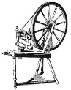**We look forward to seeing you soon**

**Forthcoming Meetings**

**January: Carding and Blending**

We hope to assemble a collection of different tools and pieces of equipment for you to experiment with.

These could include:

* carders (both flat and curved)
* a drum carder
* a blending board
* a flick carder
* combs
* hackles

If you have anything, which you can bring along to the meeting, it will add to the range and number of items available. You do not have to share your personal items with others unless you wish to do so but it can still demonstrate the variety of equipment available.

There will be a good selection of coloured wool tops available for you to use so you can allow your imagination to create a riot of colour.

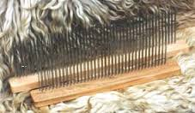 With such wide expertise in the guild, there should be some help with unfamiliar pieces. The aim of this day is to experience different ways of carding and blending fibres and colours and to see the merits of the different items.

**February: Inkle Weaving**

Members £5 Visitors £20

Rob Dunster is an inkle loom weaver, who also makes inkle looms.

He and his wife will come and do a workshop from 10am -4pm without a restriction on numbers. They will bring a couple of inkle looms with them and will demonstrate warping an inkle loom and basic weaving.

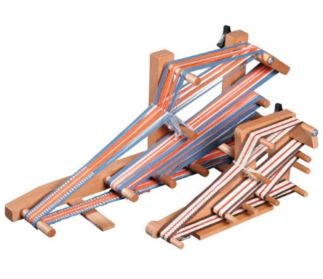This will follow a talk lasting about ninety minutes.  He feels that it is too complicated to try and teach pick up patterns to a big group but they will bring a small table loom warped for pick up, which his wife will demonstrate.  If any of our members want to bring their own inkle looms, he is happy with that and he will help to sort out any that don't work well (e.g. problems with the tensioning device).  He will bring looms and bits and pieces to sell but won't be offended if we don't buy!

**March: Making Corded Necklaces with Lesley**

This is intended to be a light-hearted day, where we will experiment with making cords on the spinning wheel and using them to make soft necklaces, which are great for winter wear. Look in your stash for items in colours you like to wear.

What you need to bring:

* Any oddments of handspun yarn
* Fancy thread such as lurex or silk for plying
* Sewing threads for plying or wrapping
* Coloured fibres such as wool or silk tops.
* Clear glue for fixing the thread to the clasps

Lesley will bring a selection of very fine coloured silk, rayon and cotton yarns, some silk and lurex threads and other oddments.

She will also have a selection of magnetic clasps for kumihimo threads as well as a range of Tibetan Beads. These will be available for sale at cost price.

You should go home with a finished necklace and have the knowhow to create more.

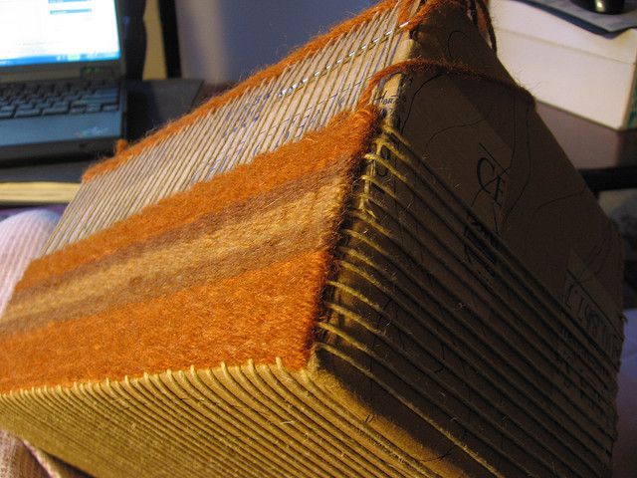**Guild Project: To Weave A Bag on a Box**

Before the September meeting, when we should reach the weaving section of this project, we need to spin and dye the yarn. The afternoon of this meeting can be spent spinning. You could spin some of the carded and blended fibres or you could spin some white fibres ready for dyeing at a later stage.

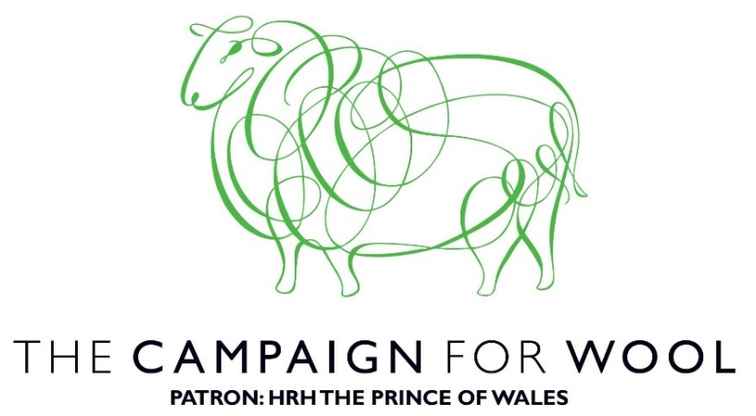

The Prince of Wales launched the Campaign for Wool in January 2010 as an initiative to expand the market for British and Commonwealth wool and promote awareness of its environmental benefits.  
   
On hearing about the low prices British farmers were receiving for their wool, The Prince of Wales convened a group of representatives from the fashion and interior design industries.   
   
His Royal Highness is passionate about natural sustainability and knows that the production of wool involves far lower carbon emissions than man-made fibres. Carpets made from wool also reduce heating costs and provide immeasurable safety benefits than their synthetic counterparts.   Unlike many man-made materials, wool naturally biodegrades at the end of its useful life.  
   
On a freezing cold day in January, The Prince of Wales launched the Campaign in front of a group of fashion, carpeting and insulation industry experts. In his speech, The Prince highlighted the many benefits wool had to offer. Not only is it a sustainable, versatile material which keeps us warm and cool at the same time; buying wool rewards some of the hardworking sheep farmers in the world.    
 A firm supporter of sheep farmers, The Prince was interested in seeing how the benefits of this material could be better explained to people so that they appreciated the benefits of choosing a natural product. As a result, The Campaign for Wool has seen wool growing organisations from the United Kingdom, Australia, New Zealand and Norway working together to remind the world of wool’s usefulness.   
   
In 2010, the Campaign for Wool staged London Wool Week where fifty-five retailers came together to promote wool. Major British retailers supported the initiative which saw a herd of sheep grazing on a newly turfed over Savile Row.  
   
In 2011, support for Wool Week increased further with famous fashion brands and designers including Dame Vivienne Westwood and Paul Smith lending their names to the woolly cause.   
   
The Prince of Wales and The Duchess of Cornwall attended the launch of the Wool Modern Exhibition at in London where they 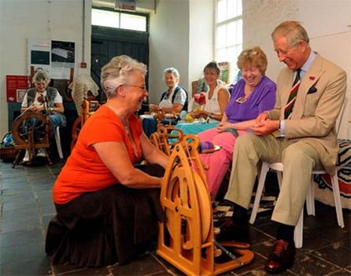joined renowned figures from the fashion and design industries to view the best of wool in carpets, insulation products and fashion pieces. Wool Week is now being recreated in a host of international cities, including Milan, Madrid and Oslo.

**Double Knitting Workshop**

**Saturday 12 September**

The September workshop in the smaller room at Widford Village Hall was a very pleasant meeting led by Juliet Bernard.  I hesitate to categorise Juliet’s main profession as she is involved in so many things but suffice to say that she is heavily into yarns and knitting, as well as being a member of our Guild.

As is so often the case, it’s easier to do double knitting than explain it in writing!  The fabric is double-sided, i.e., the smooth (stocking stitch) side appears both sides, with the pearl stitches ‘hidden’ in the middle, and there are two stitches on the needle for every single stitch of pattern.  Hmm..., as you see, difficult to explain on paper.  Juliet explained the technique and provided a nice hand-out with pattern chart to get us started.  It was a very quiet meeting as we all concentrated on counting stitches to get the pattern correct on both sides, one a mirror image of the other.  It is quite possible to have one pattern on one side and a completely different one on the other but Juliet agreed that this is really quite tricky.

The resulting fabric is quite thick and firm, and is mostly used for hats and scarves in very cold countries.  I think it would also make a very nice blanket, or even bedside rug.  Definitely a technique worth exploring further.

**By Mary Hicks**

**GUILD CHALLENGE 2016**

**‘DYE A BUNDLE’**

The Guild challenge for presentation at the October 2016 meeting is a test of creativity. Each bundle will contain a variety of yarns and fibres with a measure of pigment, wrapped up in a piece of fabric that is firmly tied to prevent premature viewing.

If you take up the challenge, you will be required to cook this up – full instructions will be supplied – at which point you will discover your colour.

When opened and dried you are invited to create anything you like using some of each of the items in your bundle. You don’t have to use everything and may add other things to complete your chosen work of art/craft.

This is a great way to see how different the same dye looks on different fibres. It is also an opportunity to see the diversity of creativeness in our guild.

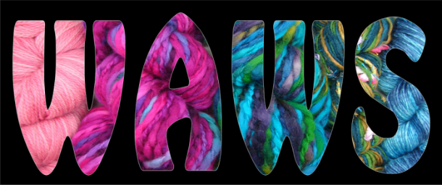Sunday 17th January 2016 from 9.30am

at

Marriot Hotel, Old Shire Lane, Waltham Abbey, EN9 3NX (Jn 26 off the M25).

Michele will be delivering spinning and crochet while Asela will be delivering felting workshops during the day.

We would appreciate members assisting in demonstrating on the stand (spinning/ weaving). It is a lovely venue and there are plenty of opportunities to shop- in case that stash is actually starting to look bare - (I jest)!

If you would like to join us please contact Mary or Carolyn.

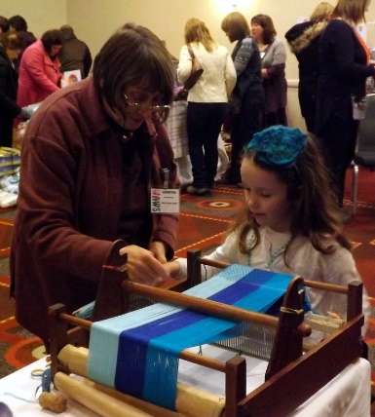

 **National Exhibition 2016**

**at Killerton House, Devon**

**“Threads in Time”**

The South West Region is looking forward to hosting the National Exhibition 2016. We are fortunate to be at Killerton House, a National Trust property in the heart of Devon. It has the largest collection of costumes in the National Trust with over 10,000 pieces dating from the 17th Century. The title of the exhibition reflects our collaboration showing quality pieces, old and new. The Association will use the downstairs rooms in the house for the National Exhibition. Killerton uses the rooms upstairs for their own costume exhibitions. The theme of their exhibitions changes every year. In 2016 the theme will be “Fashion to Dye For”. Killerton is centrally located within the region and is just 20 – 25 minutes away from the beautiful cathedral city of Exeter. There are many other National Trust properties in the region. Accessibility is good at Killerton with a buggy to take people from the reception area to the house. The gardens are lovely and there is a restaurant and plant centre. We are working with Killerton to integrate our craft skills with their fashion theme. We will have displays of our craft skills using colour in the upstairs rooms alongside their costumes so that we can show the public what our craft entails and how these crafts have been alive for centuries. We hope to organise tours of the local woollen mills where fleece is processed into fibre and yarn. There will be more details to follow and these trips will be bookable. We also have the use of the Discovery Centre at Killerton where we can run workshops with a colour theme. As well as thinking of the general public, we also intend to run some workshops specifically for Guild members. Watch the Association Journal for more news.

**Entries are invited from Guilds on behalf of their members**

**Entry Criterion**: Items need to encompass at least one of the crafts of weaving, spinning or dyeing. Other crafts can be used to augment the work. The item need not be made into an article: a length of hand-woven cloth, skeins or balls of handspun yarn and hand-dyed yarn or cloth are all acceptable.

**Submissions will be sought in two categories:**

**Selected Work: Closing date for submissions is 6 May 2016**

* Submissions will be selected anonymously by a panel of expert selectors in their field (who will remain anonymous themselves until the exhibition)
* Submissions will be by photograph (please do not send item at this stage) which needs to be attached firmly

to the individual entry form A

* Samples or feelie pieces need to be secured to the entry form. This is not obligatory, however, such pieces

do help the judges and can be used in the exhibition for handling by the public instead of them attempting to

touch the real thing

* Entry fees are in two stages: There is an initial small fee per item for submission (£3), which pays for the

selection process. If pieces are selected an additional hanging fee (£6.50) is payable which pays for equipment for hanging and return postage

* Guild Secretaries will be informed which items have been selected and where they are to be sent prior to the

exhibition

* Submission for selection is only by photograph so good quality photographs assist the judges greatly
* Photographs are limited to no more than two A4 sheets of good photographic paper
* It is essential that nothing in the photographs can identify the entrant
* Photographs will not be returned after selection
* Submissions are limited to two entries per member and joint submissions are permitted
* There is no limit to the number of submissions by each Guild
* All the submissions will be sent together in one envelope from the Guild Secretary
* The decision of the selectors is final

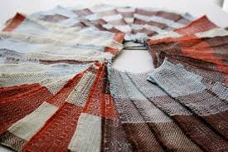

**Open Section: Non-juried Work “Bookmarks”**

* All entries will displayed if accompanied by the appropriate information on a label and the hanging fee
* Bookmarks will be 20cms maximum length and 5 cms maximum width
* Bookmarks will not be for sale and will be returned to Guild Secretaries after the exhibition
* The Exhibition Committee will need to know in advance how many bookmarks will be sent by each Guild

- there will be an email query to Guild Secretaries

* The hanging fee for bookmarks will be £3 per item
* Bookmarks are not restricted to craft, for example, they could be knitted, crocheted, tatted, woven, braided –

whatever shows the creativity of entrant.

**“Needlework in Art”**

**November 12th Talk by Clare Ford-Wille**

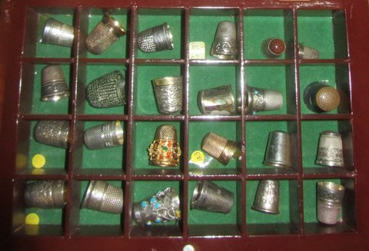A few years ago Clare started to collect sewing accessories. Having started with a small item from Robert Burns Cottage, she then discovered the specialist sale in Birmingham, where she steadily added to her collection. This once annual sale has now become a twice-yearly event in Warwick. Clare brought a representative selection of her collection for us to see and handle.

The general thrust of this talk with slides was on how needlework accessories were depicted in art from the 15th to the 20th centuries. Clare broadened this to include spinning and weaving for our benefit.

Paintings in this period reflected an increased wealth in the upper bands of society and with it, greater leisure. The earliest images were from religious manuscripts and showed Mary, Joseph and the baby Jesus in a simple domestic setting. In one of 1450, Mary was shown weaving, whilst Joseph was occupied with his carpentry. This was a common depiction, at the time, as ordinary people would readily relate to such images. In another painting from the Netherlands, Joseph is seen cutting up socks to make swaddling bands.

Clare showed several paintings, where wealthy women could be seen sewing. In one, where they could be seen wearing the butterfly head dresses of the early fourteen hundreds, they were shown spinning flax in a grand interior with glass in the windows. So many of the paintings depicted women sewing or spinning.

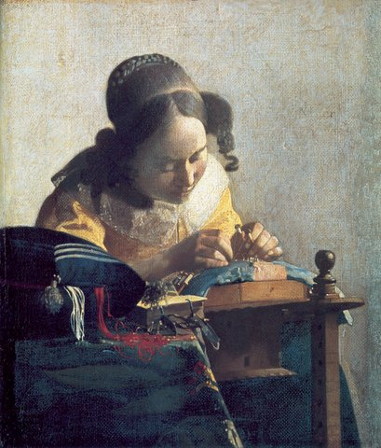Vermeer was a master of female portrait. His style is very recognisable and “The Lace maker” is one of his most famous portraits. He was obviously painting from life as the girl is holding her bobbins taut while she places her pins to hold the position. I have since found many pictures of that period, which show lacemaking. As a former lace maker, I can even work out their origin from the shape of the bobbins and that of the pillow.

Clare showed us a painted by Judith Leyster, a friend of Frans Hals. In it, a man is leaning over a woman, who is trying to get on with her sewing. I had never heard of Judith but Clare explained that, although she married a painter, a woman’s career was supposed to end on marriage.

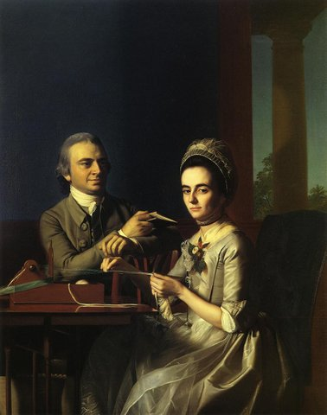In a later American painting, there was much discussion about Mr and Mrs Mifflin. What was she using? It was very hard to see. There seemed to be some warp threads so it could be a loom. Later investigation found some clearer images and it was indeed a small loom, which was used to weave narrow bands of fabric such as ribbon or tape.

Clare had such an extensive set of photos that it is impossible to describe them all. Both Velasquez and Murillo included a winding frame, Millet showed a shepherdess knitting, Angelica Kauffman painted tambour lace. There was netting and embroidery. We could see a cap 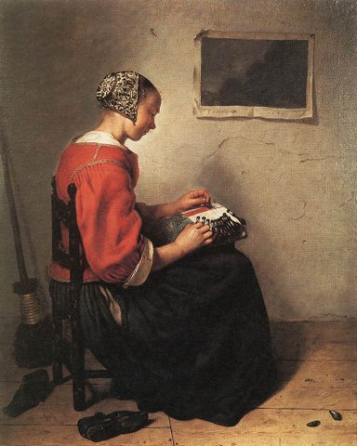of Spanish blackwork in a painting of a lace maker by Casper Netcher. My notes covered five pages of detailed text.

Once home, I went online and found more examples of paintings, which portrayed women busy with some textile activity.

During the break, we were able to admire and enjoy a selection of needlework boxes and cases from Clare’s collection.

Thanks to Ann at the museum, we were able to extend our evening to finish the second set of slides, which showed examples of needlework accessories such as scissors and thimbles.

This was a very interesting talk, particularly since Clare had done some very specific research to find illustrations of spinning and weaving for our benefit.

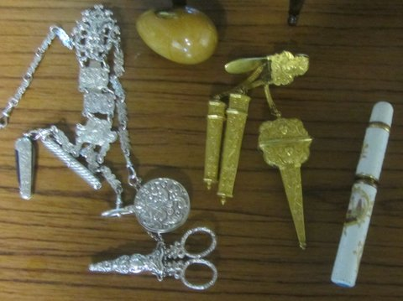

By Lesley Ottewell

“**Where were the paparazzi....?**

I’m sure most members will be aware that the Guild is to be the subject of a short film by two amateur film-makers, Ed Kinge and Sally Reed.  I think Ed first suggested the idea to Hilary and Chris who were doing a demo at Little Berkhamsted Arts & Craft Fair in July.  The Committee were broadly in favour of becoming film stars especially as we would be allowed to use the resulting film for our own publicity.  I then met Sally at the Epping Horticultural Society Annual Show in Epping where she, too, had a stall.  Sally spent quite a while during the day filming my feet treadling away (I really wished I had worn better shoes!).  Thereafter, Sally and Ed also followed us to Mill Green in September and came to our AGM.  They also visited Sue at Perry Green to capture her sheep, dye garden and loom.  Finally, I think (!), Sally visited Asela at home last month to do some recording since extraneous noise had spoiled the sound at some of the outside events.  I went too to lend moral support and, it turned out, hold up curtains to provide shade for some late shots of Asela at her laptop editing the website.

So, with all this attention from Sally and Ed, I was a little disappointed that my arrival at Asela’s went unrecorded by the wider media, hence the headline...

We should see the finished version sometime in the New Year.  Ed is a member of Potters Bar Film Makers, and you can see one of his videos on their website, hopefully soon to be showing West Essex & East Herts Guild!”

By Mary Hicks

**… and finally,**

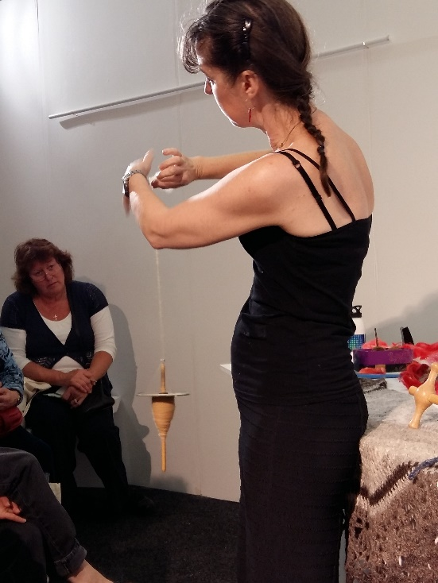From the Twisted Yarn blog about the Knitting and Stitching Show at Alexandra Palace….”And then I went to a brilliant talk by Michele Turner of the Association Of Guilds Of Weavers, Spinners, And Dyers, all about spinning. This is a woman who can make a drop spindle out of a banana!

She said it wasn’t quite the right kind of banana, but I was too shy to ask what could have been improved on the fruity front. I’ve been holding out on learning to spin for a long time, because I know it would eat up what little non-yarn life I have left, but there is a bunch of bananas in the fruit bowl not ten metres from where I’m sitting, and it’s very tempting to try this new skill. She also made a more conventional spindle using two CDs, a length of doweling, a hook, and a rubber band.

Oh, and she spun some rather fine (in both senses of the word) dog hair. “

We are so proud of our Shelly!

If you would like to contribute to the next edition of Threads or would like to add some information to our website, please contact Asela Ali at palmsnpeacocks@gmail.com

***

Lead Workshops will need to be booked through our Treasurer and paid for in advance.

***

If you would like to propose a speaker or workshop or would like us to come and demonstrate, please contact our Programme Secretary.

**\*\*\***

To borrow equipment or books from the Guild library please contact a member of the committee.

***

THREADS

http://cf2.primecp.com/images/clear_pixel.gif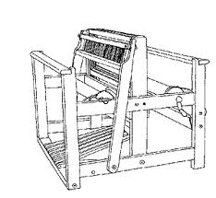

Monthly meetings at Harlow Museum

Muskham Road

CM20 2LF