contacts
West Essex & East Herts Guild of
Spinners, Weavers & Dyers

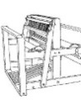

March 2015

Threads
Chair | Carolyn Green
Vice-Chair | Lesley Ottewell
Secretary | Mary Hicks
Treasurer | Cate Barnett
Publicity Officer | Asela Ali
Programme Secretary | Sue Prior
Committee Member | Chris Lane
Guild Website
www.westessexeasthertswsd.weebly.com
Members of the Committee 2014/15
Guild Programme 2015
Thursday 9th April  7pm -9pm  Harlow Museum | Talk by Connie Flynn  ‘My Shetland experience’
Thursday 14th May  7pm- 9pm  Harlow Museum | Spinning Workshop  Bring and buy sale.  Panel evening – bring your questions about your craft.
Thursday 11th June  7pm- 9pm  Harlow Museum | Talk and demonstration by Paula Armstrong  ‘Weft based Twining’
Saturday 11th July  10am – 4pm  Bell House, Bell Lane, Widford | Dyeing workshop  Shibori scarf project

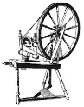
We look forward to seeing you soon
What I did in the Holidays by Asela Ali (Age 4…)
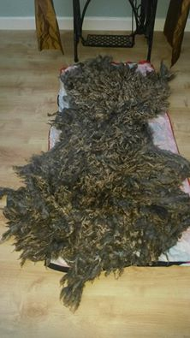
It was an unusual winter and I took the opportunity during the warm days to have good clear out and work through my various stashes. It also happened that there had been a conversation at home about drinking hot chocolate in front of the fire and eating satsumas and chestnuts, which prompted a thought that I needed a rug. So therein lay the dilemma – to rag rug, to spin and crochet, or to felt.
I knew I had bought some washed fleeces to spin, but I also found that the fleeces I have accumulated (2 alpacas, 1 Jacob, 2 Suffolk’s) were still in good condition. There would not be enough time to spin or rag rug, so I fell back on what I know best – felt.
In 2013 I worked with Thomas Horst in July on his gowns and in October making samples with raw fleece. I contacted him through Facebook with my idea and he talked me through the process – which I had to adjust for my own studio facility -.
After skirting and de-vegging, I placed the fleece shaved side up and lay on my fibres. After some time with my trusty sander there followed hours of washing and rinsing before a final drying away from inquisitive cats.
Thanks to a beautifully varied Jacob fleece from Hazel Mead and live supervision from Ohio I had my Xmas rug…and hot chocolate!
How I got started
By Audrey McNeill

I first became interested in spinning when seeing a friend magically produce yarn from fluff. I then acquired a drop spindle and after a short lesson and a few very weird efforts started to produce something that looked vaguely like yarn.
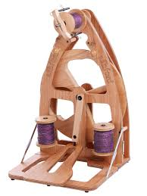

However, my relationship with the drop spindle was somewhat hit and miss – fortunately I hit the settee rather than the hard floor when I threw it down in disgust at one point. After this, I decided to try a spinning wheel. I tried spinning on one at Fibre East and decided to buy one. My friend introduced me to the guild to try a few different wheels and having decided I bought an Ashford Joy and then joined the Guild.
Knitwear – Chanel to Westwood
19 September 2014 – 18 January 2015
Fashion and Textile Museum, 83 Bermondsey Street London SE1 3XF
By Lesley Ottewell
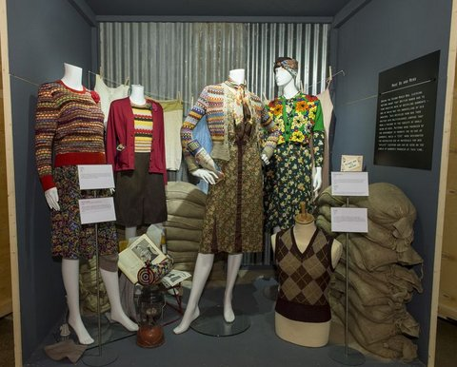
The Fashion and Textile Museum’s latest offering was ‘Knitwear: from Chanel to Westwood’ and featured the collection of Mark and Cleo Butterfield. Therefore the exhibition emulated their personal approach rather than creating a comprehensive historical overview. The garments therefore were displayed in loose themes.
Some of the examples of the knitwear in the Victorian and Edwardian era included the men’s vests. In those days knitting was not limited to women, it seems that many men, including soldiers and sailors, knitted as a practical pastime.
By the advent of the First World War women’s attitudes to dress were changing and knitted sportswear had become a popular choice for cycling, golf and motoring. Clothing needed to fit well, be comfortable and flexible enough for the wearer to feel unrestricted. Even swimming costumes were knitted. Remember those itchy garments that held the water so much.
It was Chanel in the 1920s who introduced striped and checked jersey twinsets in neutral colours who remain understated classics of the 1920s modernism. There were some very appealing dresses and suits, which were very cleverly cut. One dress, had what appeared to be a shrug with long sleeves but it was placed in front of the neck and held in place by a buttoned flap.
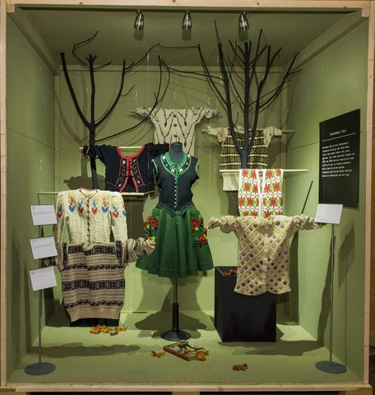
The archetypal fairisle jumper was well represented. Its popularity stemmed from one being given to Edward, Prince Of Wales, who wore it to play golf. The patterns are achieved by using only two colours at a time. Each colour combination is worked for two rows with with one colour changed for the next two rows.
During the Second World War, clothing rations meant that British women had to find creative ways of recycling garments – this included unravelling old sweaters, which then were knitted into multicoloured jumpers. The government who promoted the re-use of garments would issue a CC41 mark, which designated the restricted use of materials for new ‘utility clothing’: ‘Make Do and Mend’.
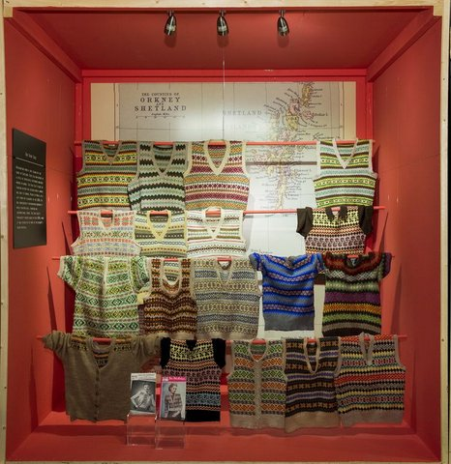
In the 40s Hollywood stars were photographed and filmed by the studios wearing knitted garments. Lana Turner was known as the sweater girl.
I really enjoyed seeing the folkloric section, where traditional designs from Scandinavia, Central Europe and the Baltic States were imitated and transformed. These were all the rage in my childhood and enabled hand knitters to use leftover yarn to create colourful, patterned garments, particularly for children.
The more recent years were represented by garments, made from knitted fabrics and sewn together. They draped well and could be more figure hugging than woven fabrics. Having expected to see knitted garments I was at first disappointed to see the sewn garments but as the whole collection was the work two people, it put a different slant on the whole experience.

The West Essex & East Herts Guild of Spinners, Weavers & Dyers
Minutes of Committee Meeting held on Saturday 10 January 2015 at 10.00 a.m. at Harlow Museum
Present:
Carolyn Green - Chairman
Lesley Ottewell - Vice-Chairman
Asela Ali - Publicity and Threads
Cate Barnett - Treasurer
Sue Prior - Programme Secretary
Chris Lane - Committee
Mary Hicks - Secretary

1. Apologies for Absence – None, everyone present.

2. Minutes of Previous Meeting held on 1 October 2014 were signed by Carolyn as a true record.

3. Matters Arising - None not covered elsewhere.

4. Arrangements for Future Meetings

4.1 Since so few members had booked on to the February Spindle Spinning Workshop with the Leonards, Mary suggested this be cancelled. It was
decided eventually to make a final decision at the end of the day after discussion with the members present.

Post-meeting Note: Decided to cancel Leonards and Widford Hall and replace with another spinning workshop including in-house tutorials on topics often mentioned, e.g., Andean plying, the correct way to card, etc. Asela offered to add an FAQ page to the website, which everyone thought an excellent idea.

4.2 Sue undertook to order sufficient Bourette silk yarn from Texere for everyone for the shibori scarf project which would be started in March. The cost would be about £8.00 per person plus postage.

4.3 Connie Flynn, feltmaker, had been booked for the April meeting, at a fee of £80, to talk about her textile degree course and work in Shetland.

4.4 The May spinning workshop and Panel Evening would require further planning and members would be encouraged to raise questions via the new FAQ page on the website.

4.5 Paula Armstrong had been booked for June for a talk and demo on weft-based twining.

5. Possible Alternative Venues for Meetings

5.1 Mary reported that Science Alive was now planning to charge the Guild £20 per hour for future meetings. Although this charge was not perhaps unreasonable for evenings when staff, heating, etc. were supplied, Mary had queried the charge for days when the Museum was open anyway. This was therefore under further discussion, but Mary had agreed a fee of £40.00 for today, 10th January.

5.2 There was much discussion as to whether the Guild should take this as an opportunity to find a more suitable venue, with a better room, proper kitchen, etc. Prime considerations would be availability of parking and storage for the library. It was also generally agreed that the venue should probably be in a town, rather than a village, for ease of travel.

5.3 Cate had researched details of two halls: the W.I. hall in Harlow, which was £12 per hour but parking might be an issue; and High Wych village hall, £20 per hour (£16 for locals) but only £5 per hour for their committee room.

5.4 Asela undertook to find out if Pets’ Corner might be a possibility, and also to try to obtain a list of community halls in Harlow.

6. Correspondence (including Association AGM)

6.1 It was agreed that the Guild had no nominations for vacant posts on the GPC or Journal Committees, nor any propositions or points for discussion this year.

6.2 Mary reminded the meeting of the GPC offer for one of its members to visit and give a presentation on the work of the GPC and what it does for individual Guilds. After discussion, it was decided that this was not of interest.

7. Finance

Cate reported that she had transferred money to the Deposit account as previously agreed. Cash in hand was now £260.66.

8. Any Other Business

8.1 Arrangements for the Waltham Abbey Wool Show were finalised.

8.2 Carolyn asked whether the organisers of last year’s Family Event at Forty Hall, Enfield, had made contact. Mary undertook to write to ask if they were planning a similar event this year. Mary

8.3 Lesley offered to put together a list of people who give talks as an aid to future planning. It was agreed that this would be most useful.

9. Date of Next Meeting

This would be held on Wednesday 29 April at 6.30 p.m.
Policemen getting younger? ...Weavers too!
Lucas Barnett with the scarf he wove recently for his mother.
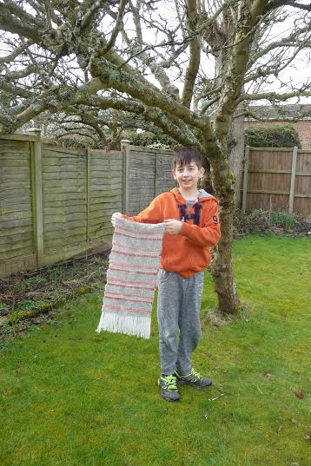
The orange wool was carded, spun (taught by Carolyn in the Museum garden in 2013), washed and dyed by Lucas. When it came to plying, his grandmother said she wasn’t sure how to do it but Lucas was not to be dissuaded: “It’s easy, Granny: Carolyn said you just turn the wheel the opposite way” and off he went plying away merrily.
The weaving was a project he did when he came to stay at half term, and he diligently helped to warp up the loom and then did all the weaving himself with music playing from his earphones: a thoroughly modern weaver!

Swedish Nalbindning for Woollen textiles
By Sue Prior

I can’t remember what brought this course to my attention but I have wanted to learn how to do nalbindning for many years, so got quite excited when I saw it listed amongst several others for the Nordic Themed Weekend at West Dean College. I first heard of this ancient textile technique that pre-dates knitting when I saw a beautiful, simple little bag on the pages of Spin-Off’s Gallery – the section where photographs of readers’ work are shown. I couldn’t find out much about it anywhere.
Later, there was a tiny article in The Journal which was impossible to follow and then the writer of that article came to the Cambridge Guild to talk about dyeing with fungi. She had made some objects using the technique but her ten minute demonstration wasn’t anywhere near enough to learn how to do it. Subsequently, I bought a very expensive little booklet from the USA which threw me completely as the very first photograph didn’t match up at all with its caption. Articles on the internet have improved greatly since I first started googling for them but I still couldn’t get my head around it – I think partly because there are so many different methods and different ways to describe them on paper. So, at last I had the chance to learn first-hand from a real live person, Lucinda Guy, author of numerous knitting books, several of which have a Scandinavian theme. The following day she was running another course entitled “Northern Knits – folk knitting techniques for garments”, which also looked interesting.
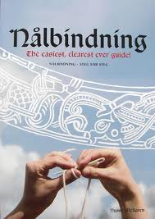
I wasn’t overly keen on the long drive to West Dean on a miserable, wet December morning when I was feeling groggy with a cold, leaving home at 6.30 a.m. to get there for a 9.15 start! However, when I walked into that lovely old building and saw the beautiful Christmas tree, stockings hanging above the huge fireplace in the entrance hall and examples of different crafts framed on the wall, I knew it was going to be a good day! There were ten of us on the course including one man, ex-navy with few teeth but lots of tattoos and a very demanding woman, sitting on my right who whinged all day long! Lucinda was lovely, a good teacher and extremely patient, especially with the aforementioned woman! She had brought along lots of lovely knitted articles which feature in her most recent knitting book. Included in our fee was a nice wooden nalbindning needle, a ball of softly-spun, cream singles yarn and other coloured yarns to use for contrast. At last, sitting with these other people, I realised I hadn’t been extra thick in not being able to work out how to do it as we all struggled to master the technique. It is unlike anything I have done before and is hard to unpick so, if we went wrong, Lucinda encouraged us to abandon our attempt and start again to give us lots of practice doing the first few steps. She didn’t want us making notes nor taking photographs as she felt we would learn more quickly if we just concentrated on getting it right. In no time at all, each of us had a growing heap of cast off lengths of yarn with just a few loops to show for our efforts.
Once we got going, we learned how to join our work into a round and how to increase and decrease but it took most of the day to do so! We went to the dining room for coffee, lunch and tea (with mince pies!) and there was a real buzz about the place. I also managed a quick look around the beautiful kitchen gardens which I had only seen previously in summer whilst at the College for the Wholly Herb festivals. Needless to say, despite the bare trees and fairly empty beds, it still looked very impressive. I picked up the College’s “Make, Create, Discover” brochure on the way out and there are loads of short courses in art, craft, gardening, music, wood, metalwork, ceramics and textiles listed in it. The tutors are well known in their field and, although the course wasn’t cheap, I felt I got my money’s worth. We were asked to fill in a feed-back form at the end of the day and I got the impression that the College was very keen to satisfy all the students. I would definitely recommend them.
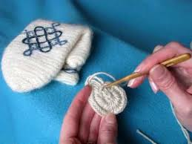

It’s all Addy’s Fault!
By Sue Pulham
“I’m going on a weekend spinning course at Whitehouse Arts” my friend Addy said. “Are you interested?” Well – never one to miss an opportunity and loving new experiences – I said yes!
We had a very enjoyable/frustrating/humorous weekend with a lovely group of ladies and by the end of it I was hooked! We started off with a drop spindle which I have to say I struggled with but all the time I had my eye on the beautiful and enticing wheels in the corner. I guess I learned the rudiments of spinning with the drop spindle and the two ladies teaching us were very patient – they needed to be. The drop spindle really is a knack isn’t it but it wasn’t fast enough for me! As soon as I got on the wheel I loved it – I wasn’t much better but knew that I could improve with practice. We all tried several wheels and I fell in love with the double treadle Ashford Joy. We touched on most aspects of fleece sorting/carding/dyeing and spinning but I could see that this was just the tip of the woolly iceberg!!
I was introduced to the Guild by Ann Mayes and Chris Lane and I have got to a lot to thank you both for there. What a lovely group of people. A more kind and helpful bunch you couldn’t hope to meet and I have learned so much but I’m only just scratching the surface. I am so grateful to you all for the very warm welcome – I feel I have made so many new friends with a common passion. Now I just have to ditch the job to give me more time..................
Calendar of Events

AGM Association of Weavers, Spinners & Dyers
18th April 2015
Conway Hall, London

Wonderwool
25th – 26th April 2015
Royal Welsh Showground, Llanelwedd, Powys

Swaines Green May Fayre
2nd May 2015
Swaines Green, Epping

Fibre East
25- 26th July 2015
Redborne School & Community College, Bedford

Great & Little Hallingbury Flower & Country Show
26th July 2015, noon till 4.00pm

K9 Dog Show
2nd August 2015
South Woodham Ferrers

Wingham Wool-work Weekend
31st October - 1st November 2015
Village Hall at Lavenham

… and finally,
When you have got around to sewing all those bits together.
When you have sworn that you will learn to knit in the round so you never have to join seams again.
When you have rinsed and blocked your carefully hand-knitted jumper….check that any animals have limited access to the room where you are laying out otherwise you may have created a new cat bed !

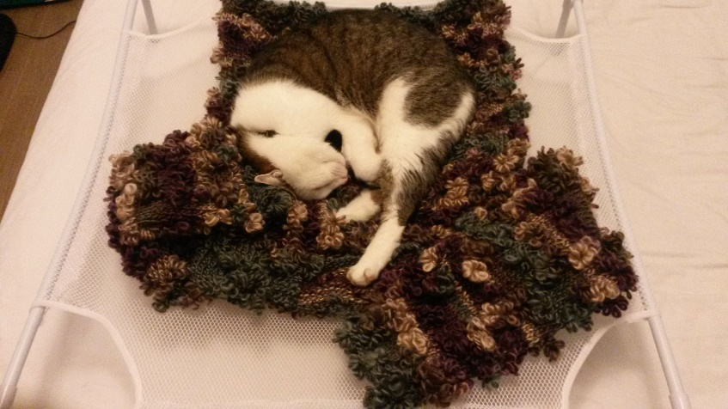

If you would like to contribute to the next edition of Threads or would like to add some information to our website, please contact Asela Ali at palmsnpeacocks@gmail.com
***
Lead Workshops will need to be booked through our Treasurer and paid for in advance.
***
If you would like to propose a speaker or workshop or would like us to come and demonstrate, please contact our Programme Secretary.
***
To borrow equipment or books from the Guild library please contact a member of the committee.
***
THREADS
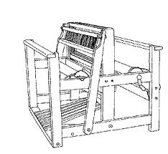

Monthly meetings at Harlow Museum
Muskham Road
CM20 2LF

