### contacts

West Essex & East Herts Guild of

Spinners, Weavers & Dyers

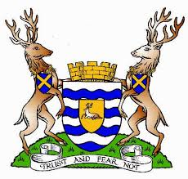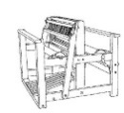

#### **September 2014**

#### Threads

|  |  |
| --- | --- |
| Chair | Hilary Hedderick |
| Vice-Chair | Michelle Rashford |
| Secretary | Mary Hicks |
| Treasurer | Cate Barnett |
| Publicity Officer | Asela Elmorsy |
| Programme Secretary | Sue Prior |
| Committee Member | Chris Lane |
| Guild Website  www.westessexeasthertswsd.weebly.com | |  |
|  |  |



**Members of the Committee 2013/14**

**Guild Programme 2014**

|  |  |
| --- | --- |
| Thursday 9 October  7.30-9.30 p.m. | Annual General Meeting  and Competition:  A Bag, no more than 8inches/20cms in any direction, excluding handles |
| Thursday 13 November  7.30-9.30 p.m. | Spinning workshop –  Bring your wheel (or other work in progress) to spin and chat.  Show-and-Tell |
| Thursday 11 December  7.00-9.30 p.m.  Note earlier start time | Christmas Social Evening |

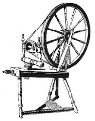**We look forward to seeing you soon**

**Handmade Event**

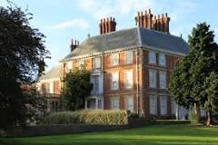

**Forty Hall, Enfield,**

**Sunday 13 July 2014**

**by Mary Hicks**

Forty Hall is a Grade 1 listed heritage house dating from 1629, now owned and run by Enfield Council. Sir Nicholas Rainton, who built the Hall, was a haberdasher and also traded in cloth so themes around textiles are quite relevant. They have a programme of exhibitions and events throughout the year alongside a permanent exhibition but, although they have held craft fairs previously, this was the first event at which they have had craftspeople demonstrating their work.

Admission to Forty Hall and its large park is free. There was a craft fair as well and live music in the courtyard outside the restaurant, so lots going on. It was a hot and sunny day and Carolyn and I were quite fortunate to be in one of the downstairs reception rooms with Sandra Barker, the basket maker, who some Guild members will know. We were just demonstrating but some of the other makers, including Sandra, had been paid to run simple workshops for children.

There was a lot of interest in what we were doing and a constant flow of people so the day went quite quickly. The organisers came to talk to us at the end of the day, and asked if the Guild could return next year to show weaving and dyeing as well as spinning. They appeared keen to try to get a group established at Forty Hall, which might work, as there’s nothing really between our Guild and London, which meets in South London. So, will wait to see what happens next.

# KNITWEAR Chanel to Westwood

By [**admin**](http://ftmlondon.org/author/admin/) on April 9, 2014 in [**Future Exhibition**](http://ftmlondon.org/category/future-exhibition/)

**Exhibition Dates: 19 September 2014 – 18 January 2015**  
Inspirational vintage fashion knitwear from the 20th century. Highlights include 1920s Chanel jersey, 1930s woollen swimwear, 1970s Bill Gibb and conceptual garments from 1980s and 90s designers Comme des Garçons, Vivienne Westwood and Julien MacDonald. An exciting combination of famous names and visually exciting pieces, the exhibition charts the influence of art movements Pop, Punk and Deconstruction alongside new knitwear technologies and design innovation.



Open Tuesdays to Saturdays, 11am–6pm  
Thursdays until 8pm, Sundays, 11am–5pm  
Last admission 45 minutes before closing, Closed Mondays  
**Tickets: £8.80 adults, £6.60 concessions / £5.50 students**  
Children under 12 are free

**Book Review**

*Counting Sheep by Philip Walling- A Celebration of the pastoral Heritage of Britain*

*ISBN 978 184668 504 0 Priced at £14.99*

**by Carolyn Green**

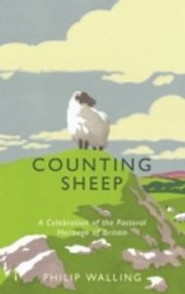

The subtitle of this lovely book says it all but I will add my recommendation. If you have the slightest interest in British history, geography, economics, arts and crafts, and sheep; there is something here for everyone and enough sheep trivia for an eternity of agricultural quiz nights.

The many uses of wool go back into pre-history and continued to develop with such success that Britain, as we know it, was built on the wool trade, hence the woolsacks at Westminster. Meat didn’t figure much until urbanisation. The British sheep, themselves, evolved slowly, each breed developing to fit the landscape they settled in and the interaction of the humans about them. Perhaps this is illustrated most markedly by the North Ronaldsay sheep and you may read some alarming facts about them, not least their taste for seagulls’ legs and feet! (...where did you get yours from Chris?).

The story of the development of the breeds we see today is fascinating to read, the importance now being meat, not wool. Several different breeds are described, sheep husbandry is explained – from birth to slaughter, and the selective breeding in between. The continued survival of rare breeds give hope for diversity. The adverse or beneficial effect on landscape is considered and the hoped-for renaissance of wool is encouraged.

The author was once a sheep farmer who later became a barrister but kept his love of sheep, which really shows in this delightful book. If you thought you knew everything about sheep, think again.



# HITCHIN FESTIWOOL

# Sunday 2nd November, North Herts College, Hitchin.

The new Atrium, North Herts College, Hitchin.   
Exhibitor Demonstrations and fashion show by the college students starring Supermodel Daphne Selfe.





**Extract of minutes of the AGM of the Association of Guilds of Weavers, Spinners and Dyers, Saturday 26th April 2013 at The Chancellors Hotel, Manchester**

Dr. Jenny Balfour-Paul, the new President of the Association.

**President’s Address:** Jenny began her address by sayfghing that the invitation from the GPC was unexpected. She at first wondered why she was asked and what she could offer. She is not really doing crafts herself now, but she does get out to a wide range of groups around the world -- that is what she can offer us. Jenny recollected a book that influenced her when she was young -- Forster's A Passage to India. Its message was 'Only connect' -- a perfect match to the Conference theme 'Reach out.' Connecting is something she does in all of her work in many ways. She said that the guilds had the local wisdom that is needed to spread knowledge of our crafts. We can capitalize on the current interest in knowing how things are made. She stressed the importance of sharing our skills with youngsters. Jenny encouraged us to get more linked up with various institutions. She will try to fly our flag in all her education work, and encouraged us to get involved with children's resources, students and share our skills in collaborative projects. She noted that anywhere she went, there was always a crowd around someone who was demonstrating practical skills -- everyone would gravitate to watch and take a sample home. She encouraged us to get out and demonstrate our skills as much as possible. She thanked us for inviting her to be President of the Association, and she told us how much we have to offer in passing things on, but there is much more scope to connect with schools and colleges. It is hard to cross over, but she stressed training the teachers. She promised to use her energy for connecting up more and more for us and suggested we look for grants for education as that is an area with lots of potential for funding.



**GUILD CHALLENGE**In line with the current trend to ‘Make do and Mend’ the challenge for his year is to up-cycle a garment of your choice spending no more than £10 in the process. For example it may be turning a jumper that is a bit snug into a waistcoat or embellishing over the worn bits of a favourite skirt.

We look forward to seeing your creations at our January meeting.

**“Reaching Out” by Mary Hicks**

The theme for the Conference: **Reaching Out,** was inspired by Manchester’s historic and pioneering association with textiles. It is currently seeking, through high-level talks between Government and the manufacturing sector, to revive its textile industry to compete on both quality and price with overseas manufacturers. Through the programme of speakers, the 2014 Conference aimed to ‘reach out’ to Guild attendees and encourage them to further their own horizons.

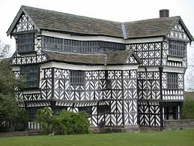

Asela, Pat and I set off early on Friday and were able to visit Little Moreton Hall, a 15th century black-and-white timber-framed building of great charm and character, in time for lunch. There was actually a spinning and weaving demo taking place when we were there! After this detour we were still able to arrive at the hotel in good time to settle in with a cup of tea. It was really rather nice to be staying in a hotel for a change rather than the usual halls, with everything going on under one roof, rather than having to trek around a campus. (The one disadvantage, of course, being the price of liquor compared with student unions!)

The Friday evening lecture was delivered with great verve and enthusiasm by **Jenny Balfour-Paul**, the Association’s new President. Jenny began with a little of her history from her days as a hippie traveller to the Far East and explained how her fascination with indigo grew. She is probably now the world expert on this dye stuff and has connections across the globe. Jenny promotes revivals of natural dyes worldwide and the use of natural dyes in education, and collaborates on dyestuffs and textiles with, among others, the Department of Economic Botany at Kew and the British Museum. Her life, work and philosophy are explained on her web-site: [www.jennybalfourpaul.com](http://www.jennybalfourpaul.com)). She feels that Guild members have an incredible knowledge and skill-set which deserves to be more widely recognised and utilised.

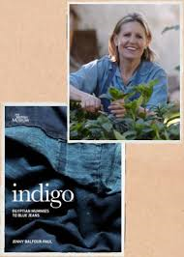

It is her ability to put people in touch with each other through her extensive global connections that prompted Jenny to consider the post as Association President. She will be an excellent ambassador. However, one of her first aims is more mundane: she is going to learn to spin…

The Saturday morning lecture was delivered by **Emma Sheldon,** a colour and materials designer, who gave a fascinating account of her experimental approach to materials and processes. It is impossible to describe in words the laser-cut and folded samples she showed us but, as ever, you can look her up on the web. Emma graduated from Falmouth with a First Class Degree in Textile Design in 2009 and gained work experience in London, Hong Kong and New York before returning to study at the RCA. Whilst there, she was commissioned by Audi, together with another student, to design a car for the future. She has exhibited widely and won numerous awards and is now (probably still in her mid-twenties!) an Advanced Materials Designer for Aston Martin.

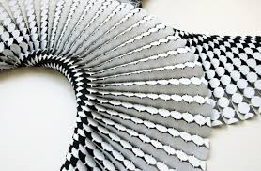

After the lecture, Pat and I headed off into the city, whilst Asela attended the AGM.

The two Sunday speakers could not have been more different. The first was **Paul Crookes**, a very entertaining Yorkshireman who established the Halifax Spinning Mill ([www.halifaxspinningcompany.co.uk](http://www.halifaxspinningcompany.co.uk)) in 2009 after his fourth redundancy from the rapidly diminishing textile industry. Having worked in textiles from the age of 16 Paul decided it would be a mistake to disregard his depth of knowledge and skill and decided to open a mill which had the ability to produce small batches of yarn tailored to the specific requirements of the customer. Paul described some of the difficulties in acquiring equipment and setting up his business, and discussed general issues associated with the processes involved in producing a finished commercial quality product. As his website shows, he will accept almost any fibre but he did say he wasn’t keen on alpaca!

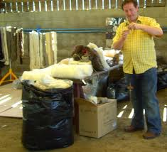

Most of Paul’s allotted time was taken up with answering questions from the floor, which he did with great honesty and humour. He had brought with him a large number of different hanks of yarn draped over a dress rail and it was interesting to note that although these were all the same actual length some appeared shorter than others due to crimp and elasticity of the different fibres. There was much activity after the lecture around the packs of yarn he had brought for sale!

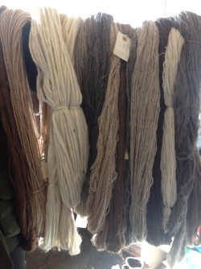

The final lecturer was **Jan Garside** ([www.jangarside.com](http://www.jangarside.com))**,** who worked as a nurse and midwife before graduating from Loughborough in 2002 with a BAHons in Textile Design. Jan produces textile artworks for interior spaces, using mostly synthetic fibres, building multiple translucent layers with surface embellishments to catch shifting light. Jan’s work was innovative and it was interesting to learn how it had evolved.

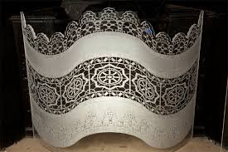

I have now attended several Association conferences and have never been disappointed. The talks are generally fascinating and I am constantly amazed at the ways in which individuals push the boundaries and produce such wonderful work. And, as always, it’s nice to catch up with Guild members from around the country and learn about their problems and successes.

**In Memoriam**

**Anita Mary Wright**

**26th January 1936 – 28th August 2014**

I first met Anita in the early 1990s when I worked in an animal feed shop and Anita would come in to buy hay for her angora rabbits. I was very new to spinning and used to sit at my wheel passing the time between customers and, of course, Anita seized upon a new spinner. She often suggested I should join the Guild, but, having visited the mid-Herts group a couple of times, I wasn’t sure it was my thing. However, she was persistent, and in the end I gave in and came along. She was always generous with her advice and assistance (she could spot a dropped stitch at forty paces!) and was a superb craftswoman in so many fields. When she broke her wrist, which was never quite right again, she found it hard to do as much as before although she kept going with her usual spirit. Her health began to deteriorate from that time and she was often not well enough to attend Guild meetings, which she missed and always hoped to return to. She was missed and her experience and knowledge has been a great loss to us all.

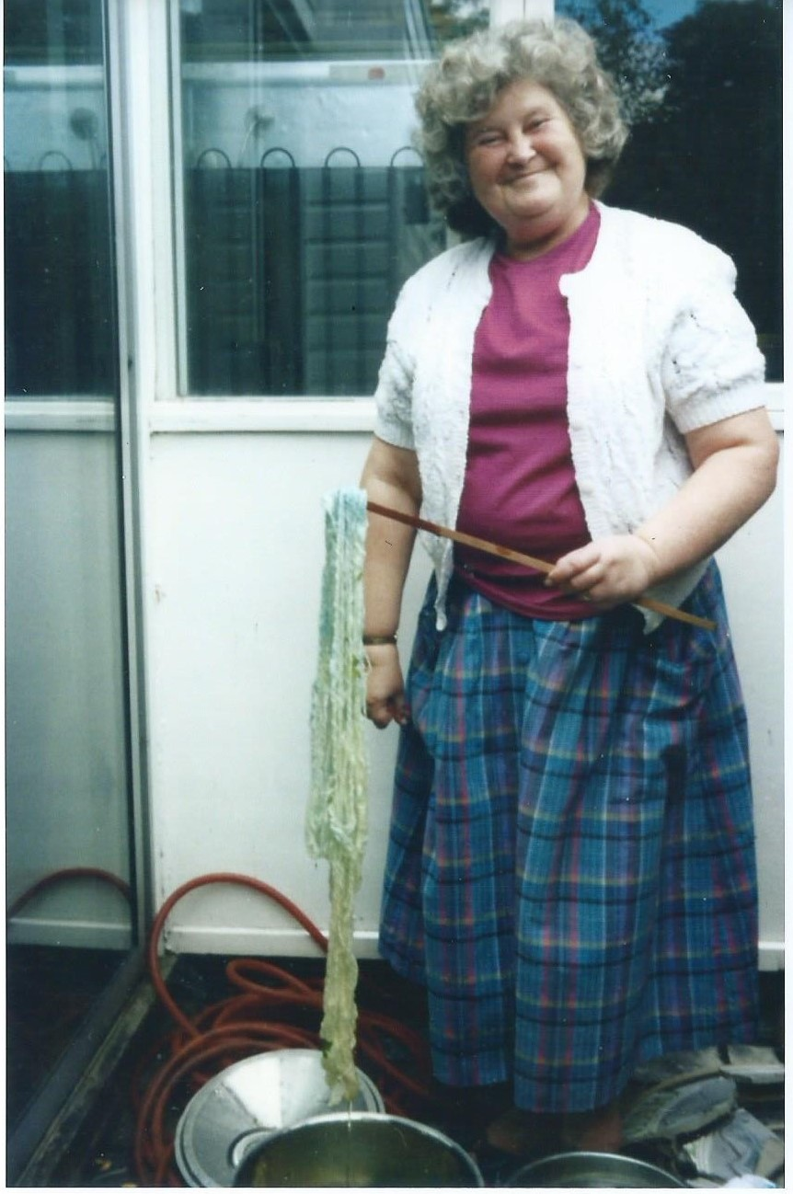

Just a little note about Anita Wright who died on the 28th August.  Will be sadly missed by all who knew her.  She was a member of our Guild for many years, her main interest spinning and knitting.  Anita and I for several years gave demonstrations at different schools in Harlow and Epping.  The young children, really loved the spinning and we even taught them to knit.  Anita was always so patient with them.  
  
Whenever I had a problem with anything I was knitting, Anita always put it right for me.  What will I do now, will miss her. We both had the same Spinning Wheels the Schacht and so did Carolyn.  
  
I remember a time when I was trying to dye some handspun skeins with Indigo and just wouldn't turn blue.  She came to my aid and I have a really lovely photograph of her taking the skein out of the dye bath and it was turning blue!!!  A lovely smile on Anita's face.  
  
Thank you Anita for all the help you have given me over the years.

*Thanks to Carolyn Green, Sue Prior and Pamela Smith for their contribution.*

**SUMMER WORKSHOPS 2014**

By Sue Prior

This summer I was very fortunate to be able to take workshops with two of my favourite American craftspeople. The first was at Fibre East with Sara Lamb. I have followed Sara’s blog for years and have great admiration for her work and the amount of spinning and weaving she turns out. Several years ago she did a knotted pile workshop with the Cambridge Guild which was excellent but I was always keen to do a spinning class with her. So I was very excited to see she was coming to Fibre East. I originally booked to do her Spinning Silk class but changed to the Spin to Weave as I thought that would cover silk anyway. Being such a fan, I already have Sara’s DVD’s “Spinning Silk” and “Spin to Weave” and maybe that was my downfall, but I felt as if I learned very little from the workshop.

Most of the participants (I think there were 9 of us so the class wasn’t anywhere near full) had spun for many years but one lady had been spinning for just a year or so. Sara had all the samples she had spun and woven for her book/DVD so I was familiar with those although, of course, I now got the chance to handle them, too. She handed out four lots of tops; Polwarth, Wensleydale, Southdown and a llama/Merino blend and we were told to split them in half, spin them and ply them, so most of the time was spent quietly spinning whilst Sara chatted and talked through her samples. At the end of the day, we looked at everyone’s skeins and Sara asked what we would use them for and then suggested how she would set them. At this point it was revealed that the least experienced lady had spun one of her fibres “z” and accidentally also plied it “z”. I think if Sara had spent more time walking amongst us and looking at what we were doing, she would have spotted this in time to correct it. An hour or so was taken up by Sara’s host, a Cambridge Guild member who put forward the argument for not plying yarns for weaving (Sara always plies!) which was interesting and was well presented but it wasn’t what I had signed up for.

Sara very briefly demonstrated her spinning technique (supported long draw) which is something I had hoped to perfect during the day. I have spun this way, but not enough to get a good, consistent yarn and I would have been grateful for some expert guidance. Maybe it was my fault for not asking outright but then a friend who did the silk spinning did ask her and was just told she was holding the silk too tightly before Sara walked off! Sara is so highly regarded for her teaching but I felt she was a bit lazy on this day. It was great hearing her talk about her various projects and she has a lovely, laid-back attitude to spinning – “Not every inch of your yarn will be precious – let it go and call it good”! The DVD’s are brilliant but what is missing from them is the personal feedback which should have been abundant in a workshop only half full.

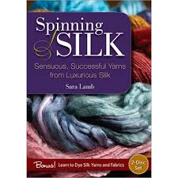

The following week, Abby Franquemont came to Cambridge to do a workshop with the Peruvian Textile Study Group to which I belong. She was also at Fibre East but both the workshops there were not offering the level of spinning and backstrap weaving that we were after. After several weeks of negotiation with the Fibre East ladies who we had to go through to communicate with Abby, we finally managed to book her to show us how to spindle spin yarns for backstrap weaving. The

Peruvians put in so much twist that their yarns are like coiled springs when not under tension. Abby took us right back to basics, getting us to spin yarn off the end of a stick. When we graduated to the spindles, she told us to keep adding twist until the yarn broke and we were all amazed at how much twist it took to do this. Unlike Sara, she watched us all with eagle eyes and was very quick to point out something I was doing wrong even though she was on the other side of the room. I wasn’t sure what to expect with Abby but she was lovely (so is Sara!) - very entertaining and full of interesting stories, tips and advice. She provided us with some beautiful alpaca fibre and some mediocre sheep wool (which, fortunately, we didn’t get time to spin!). The plan is to produce a firmly spun and well plied yarn that will stand up to being used for backstrap weaving. My earlier attempts at this were

nowhere near firm enough so that the warp started disintegrating before the weaving was finished.

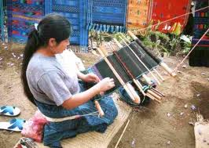I have read so much about Abby’s parents, the anthropologists, Ed and Christine (sadly no longer with us) and the family’s time spent in Peru that it was wonderful to meet Abby at last. A group of us took her out for a meal in Cambridge the night before the workshop and it was really interesting chatting about spinning in the USA and the UK. She had never been to England before but had loved her visit and is keen to return – possibly to Fibre East next year. When I said that I thought modern English spinners had been inspired to spin on spindles due to the influence of the States via Spin-Off, she was amazed. I backed this up by saying that there were far more woodworkers making

really beautiful spindles over there at a time when all you could buy here was a bog standard simple, wooden spindle. I told her that the specialist events such as Woolfest, Wonderwool, Fibre East etc were comparatively recent happenings whereas the similar American festivals have been around for decades. She was also surprised when I made the comment that the most inspiring and enthusiastic teachers seem to be from the States – herself, Judith MacKenzie McCuin, Sara Lamb, Rita Buchanan, to name a few. To that, she replied “No! How can you say that when you had Mabel Ross and still have Peter Teal”. So I came to the conclusion that the other man’s grass is always greener!

Apparently, the organisers of Fibre East had a real battle to get the appropriate licences for the four American teachers that attended this year – Abby, Sara, Deb Robson and Sarah Anderson so it is a shame that not all the classes were full (I think the maximum no. per class was 18-20 which is far too many, anyway). However, as a result, I think it is inevitable that there will be more Americans coming next year now that the infrastructure is in place. There was a list of available spinning/knitting

tutors on Ravelry (Fibre East group) and the request that you let them know who you would like to do a class with in 2015. Stephenie Gaustad was on the list so I hope she got lots of votes. I never made it to SOAR in the States but maybe that’s not such a loss if we can get their tutors over here!

**Getting the hang of it ……perhaps ! by Hazel Mead**

Now had my second attempt at weaving with the pick-up sticks workshop. I had chosen the wrong fibre to do this with which gave our tutors a headache. However with their immense amount of patience they re-arranged my attempt and kindly loaned me one of their larger heddles (which I must remember to give to Lesley when I am next able to get to a meeting) and I am now in the process of completing a very loose woven scarf. I was also very lucky to be able to use one of the tutors looms and got the idea of how to do the pick-up sticks pattern. I now have to obtain a larger heddle so that I can use my thicker yarn. The warping up I could understand so there could be hope on the horizon yet…….

**The West Essex & East Herts Guild of Spinners, Weavers & Dyers**

**Minutes of Committee Meeting held on Monday 28 July 2014 at 6.00 p.m.**

The Committee has decided to include minutes of meetings in *Threads* so that, if interested, members can read about the background to the workings of the Guild.  Being a committee member does not involve a lot of extra work but does lead to a greater sense of inclusion and enables more involvement in our world of fibrecraft.

Present:

Hilary Hedderick - Chairman

Asela Elmorsy - Publicity and *Threads*

Cate Barnett - Treasurer

Sue Prior - Programme Secretary

Chris Lane - Committee

Mary Hicks - Secretary

1. Apologies for Absence were received from Michelle Rashford.

2. Minutes of Previous Meeting, held on 8 March 2014, signed by Hilary as a true record.

3. Matters Arising

3.1 Asela had attended the AGM and voted on behalf of the Guild as previously agreed.

3.2 The Guild had provided a total of six stewards for the National Exhibition, spread over three days.

3.3 Rain had returned the Guild wheel, which was now stored at the Museum.

Action

4. Arrangements for Future Meetings

4.1 If possible, tea, coffee, etc., to be collected from Museum at August meeting to be taken to Widford for September. Hilary

4.2 Requirements for September Nuno Shawl workshop to be provided. Asela

Cost would be £20 for members, £35 for non-members. Numbers limited to 12 on basis of first responses to e-mail request for attendees.

4.3 Nominations to be sought for new Committee, in order for voting at AGM. Mary

Need to agree judging and prize for Competition at next Committee meeting. Mary

Agreed to keep membership at £20 for 2015.

Members to be asked if they would like evening meetings to start at 7.00 p.m. Chair

Remind members about ‘Make do and Mend’. Do we need more time for this? Asela

4.4 November meeting to include Show-and-Tell. Remind members. Mary

List required for Christmas meeting buffet. Sue

5. Outside Events

5.1 Knitting & Stitching Show, Alexandra Palace, 8-12 October 2014. Awaiting response from Stuart Groom regarding Guild’s possible involvement.

5.2 Waltham Abbey Wool Show, Sunday 18 January 2015. Guild has booked stand; 3-4 people required to demonstrate.

6. Programme 2015

Following Chris’s comment as a relatively new spinner, it was noted that the Programme should include some basic information, e.g., how to sort a fleece, for new members. It was also suggested that a ‘Panel Evening’ be included, when members queries/problems could be discussed and, hopefully, answered.

7. Correspondence

None not covered elsewhere.

8. Finance

Current account £ 1461.85

Deposit account 305.59

Cash-in-hand 412.14

9. Any Other Business

9.1 Agreed for 2015 that the Cake Rota would include responsibility for milk also.

9.2 Chris talked about her interest in reaching out to the community, particularly young people, and wondered if other Guild members would be willing to ‘spread the word’. Capel Manor could well be an organisation worth contacting.

9.3 Mary said that the demo at the Forty Hall Family Day for Enfield Council had been well-received and they were keen to have the Guild back next year to run a full spin/dye/weave event. They also seemed keen to establish a local textile group, and had promised to make further contact in due course.

9.4 Mary suggested publishing the Committee Minutes in *Threads.* Although doubt was expressed that members would be interested, it was agreed to go ahead.

10. Date of Next Meeting

This would be held on Thursday 25 September at 6.00 p.m.

|  |
| --- |
| **Calendar of Upcoming Events** |
| Mill Green Mill & Museum, Sunday 5th October  Mill Green, Hatfield Herts |
| Creative Fair, Saturday 11th October  St Giles Church, Nazeing Road, Nazeing |
| The Fenland Fair, 1 November 2014,  St Ives Cambridgeshire |
| Festiwool, 2nd November 2014,  The new Atrium, North Herts College, Hitchin |
|  |
|  |

**… and finally,**

The phrase used to be letters from the Editor but these days I think it is more apt to say emails from our website.

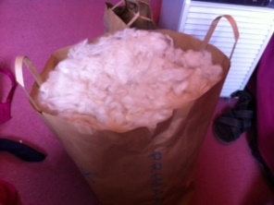We have received a number of interesting requests from a lady who learnt to spin at the Vale of Glamorgan show and wants to continue; to a request for a small piece of custom weaving for a large version of a ribbon around the neck of a ‘Chloe’ perfume bottle!

But being the cats’ mother I thought I would share this most recent request to spin this bag of fur which is not really from Primark so we have not sunk too far.

The lady was so pleased with our feedback, that she sent me a picture of its former owner, an apricot Persian named Algernon. I know you are smiling too!

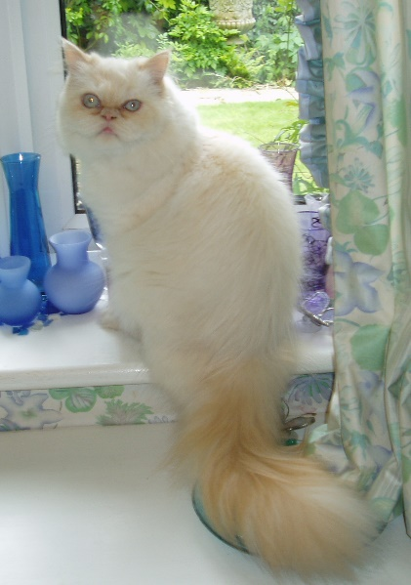

THREADS

If you would like to contribute to the next edition of Threads or would like to add some information to our website, please contact Asela Elmorsy at palmsandpeacocks@gmail.com

***

Lead Workshops will need to be booked through our Treasurer and paid for in advance.

***

If you would like to propose a speaker or workshop or would like us to come and demonstrate, please contact our Programme Secretary.

**\*\*\***

To borrow equipment or books from the Guild library please contact a member of the committee.

***

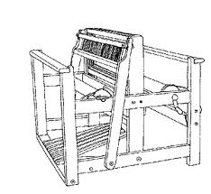

Monthly meetings at Harlow Museum

Muskham Road

CM20 2LF